MIN MAX
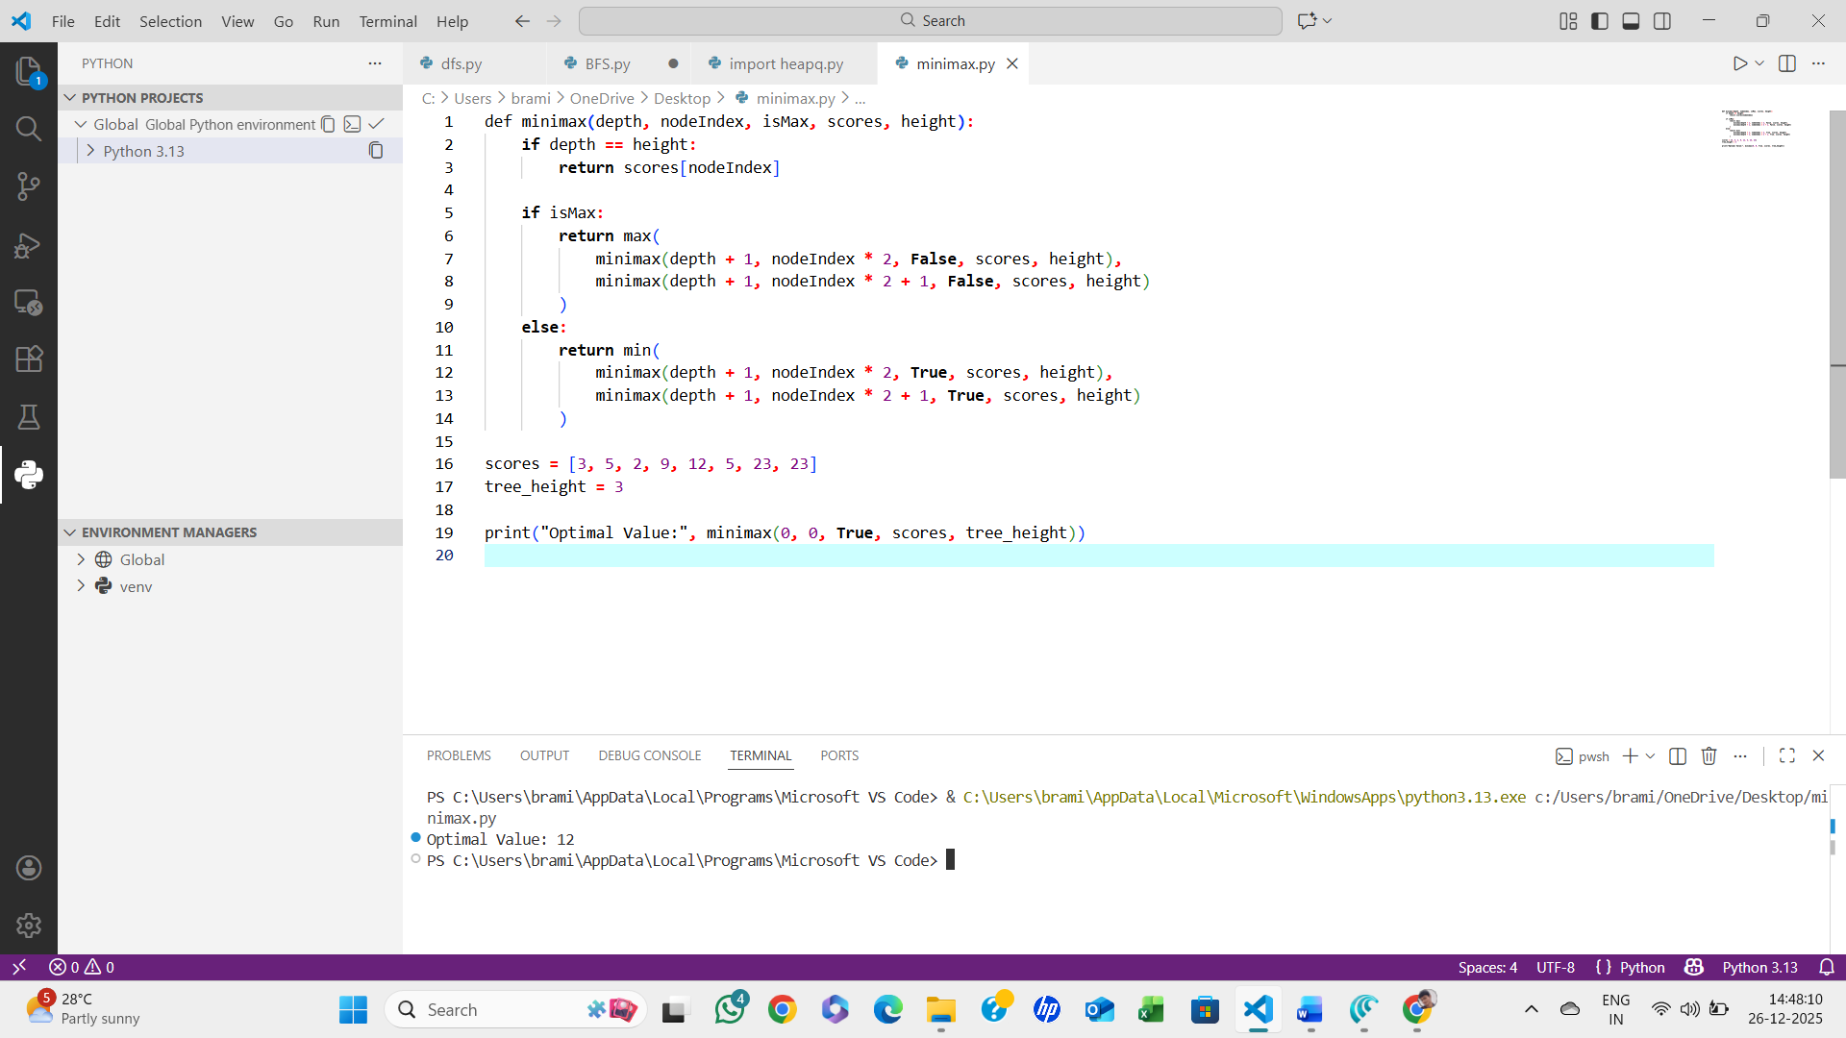

ALGORITHM:
- Start from the root node
- If the node is a terminal node, return its value
- If it is MAX’s turn:
  - Evaluate all child nodes
  - Return the maximum value
- If it is MIN’s turn:
  - Evaluate all child nodes
  - Return the minimum value
- Continue until the root value is obtained
6.STOP.

